اولا: هل الوق والسوق مناسب لشراء البيت

ثانيا: ايه الخطوات لشراء المزل ( الفلاير )
البدء بالقرض ثم .....................

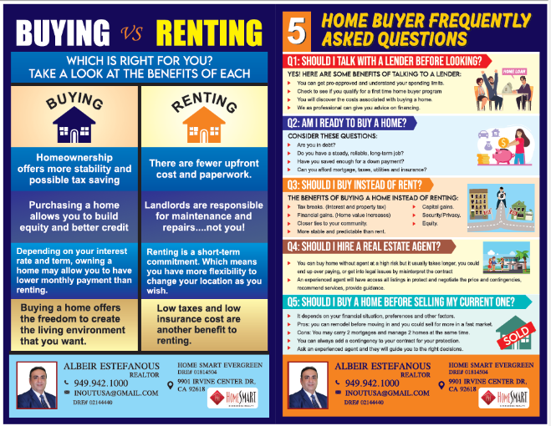

ثالثا: كيف اختار الريال ستات ايجينت بتاعي

رابعا: كيف اختار البيت ( الفلاير )
ايه الفرق بين الموبيل ههوم الكوندو والبيت والتاوهن هاوس
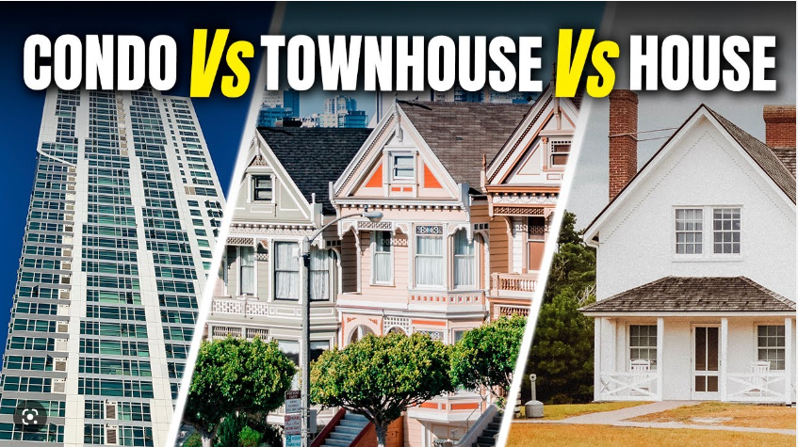

خامسا : خطوات شراء البيت
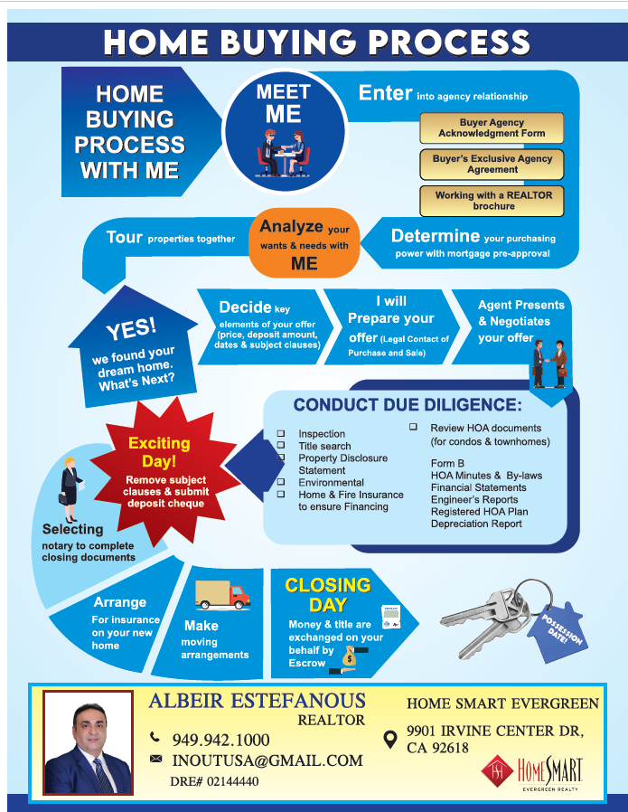

سادسا: هل دا وقت مناسب للبيع؟

سابعا: و ايه هي خطوات بيع المنزل ؟ ( الفلاير )

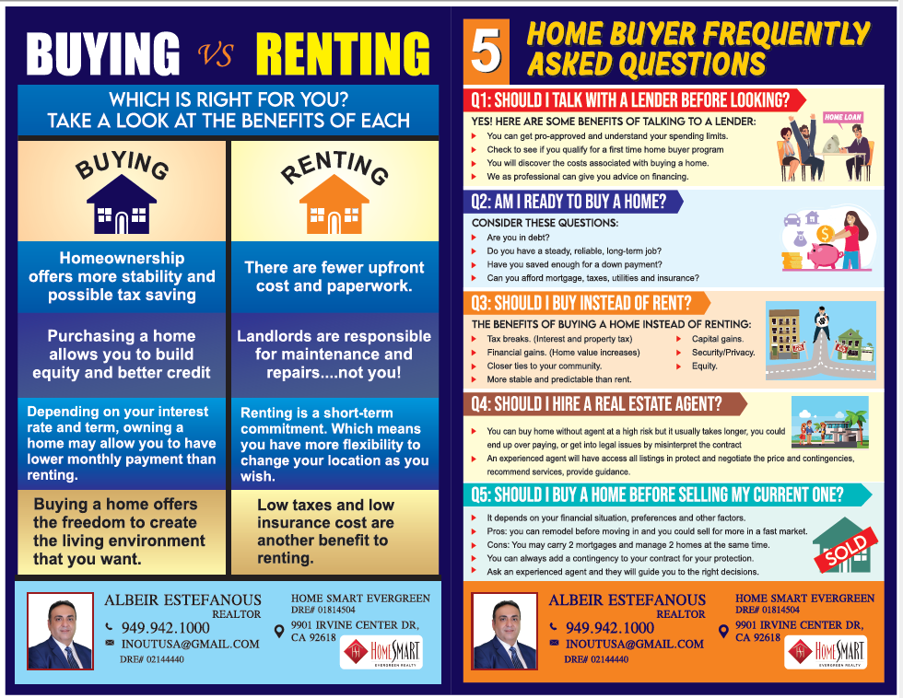

ثامنا: يعني ايه
HOA

تاسعا : يعني ايه وايه الفرق بين

Auction – Short Sale – foreclosure

عاشرا: هل هي انواع من الاراضي معينه تنصح بيها؟

What is a Condo?
A condo, or condominium, is a single-residential unit that’s housed within a larger building. Condo layouts vary by building, but most buildings have several units per floor, so you may have other units above, below, or next to you. They can be found anywhere, from luxury high-rises in urban areas to residential buildings in suburban areas.

What is a Townhouse?
A townhouse is a cross between a single-family home and a condo. They’re typically two or three stories tall and share walls with the next-door properties, but they don’t have any units above or below them. Townhouses are often a popular option for first-time homebuyers and young families, and they can also be found in age-restricted active adult communities.

5 Key Differences Between Condos and Townhouses
Now that you know what the architectural differences between townhouses and condos are, here are some ways that those differences could affect your lifestyle and your wallet.

